DATA SET REPORT
DATA SETS
- https://www.kaggle.com/datasets/raghavdharwal/cows-and-buffalo-computer-vision-dataset?utm_source=chatgpt.com
2. https://www.kaggle.com/datasets/atharvadarpude/indian-cattle-image-dataset?utm_source=chatgpt.com
3. https://www.kaggle.com/datasets/atharvadarpude/indian-buffalo-dataset?utm_source=chatgpt.com
4. https://data.mendeley.com/datasets/xc3j9v382w/1?utm_source=chatgpt.com

DATA SET CLEANING
Audit script-(Tells number of classes and images and dimensions)

CODE-(py)

import os
from pathlib import Path
from collections import Counter
from PIL import Image

ROOT = Path(r"D:\#SIH 2026")

IMAGE_EXTENSIONS = {
".jpg", ".jpeg", ".png", ".bmp", ".webp", ".tif", ".tiff"
}

print("=" * 70)
print("SIH LIVESTOCK DATASET AUDIT")
print("=" * 70)
print(f"Root folder: {ROOT}\n")

if not ROOT.exists():
print("ERROR: Root folder not found.")
print("Check the path in the script.")
exit()

total_images = 0
total_corrupt = 0
total_other = 0

for dataset in sorted(ROOT.iterdir()):

if not dataset.is_dir():
continue

print("\n" + "=" * 70)
print(f"DATASET: {dataset.name}")
print("=" * 70)

class_counts = Counter()
image_sizes = Counter()
corrupt_files = []

for file in dataset.rglob("*"):

if not file.is_file():
continue

if file.suffix.lower() not in IMAGE_EXTENSIONS:
continue

total_images += 1

# Class = first folder below dataset
relative = file.relative_to(dataset)

if len(relative.parts) >= 2:
class_name = relative.parts[0]
else:
class_name = "ROOT_IMAGES"

try:
with Image.open(file) as img:

# Verify image
img.verify()

# Reopen to obtain dimensions
with Image.open(file) as img:
width, height = img.size

class_counts[class_name] += 1
image_sizes[(width, height)] += 1

except Exception:
corrupt_files.append(str(file))
total_corrupt += 1

print("\nImages per class/folder:")

if class_counts:
for cls, count in sorted(
class_counts.items(),
key=lambda x: x[1],
reverse=True
):
print(f" {cls:<35} {count:>6}")

else:
print(" No standard image files found.")

print("\nTotal images:", sum(class_counts.values()))

print("\nMost common image dimensions:")

for size, count in image_sizes.most_common(10):
print(f" {size[0]} x {size[1]} : {count}")

if corrupt_files:
print("\nCORRUPT IMAGES:")
for f in corrupt_files[:20]:
print(" ", f)

if len(corrupt_files) > 20:
print(f" ... and {len(corrupt_files) - 20} more")

else:
print("\nCorrupt images: 0")

print("\n" + "=" * 70)
print("FINAL SUMMARY")
print("=" * 70)

print(f"Total images found : {total_images}")
print(f"Corrupt images : {total_corrupt}")

print("\nAudit completed.")
print("No files were modified.")
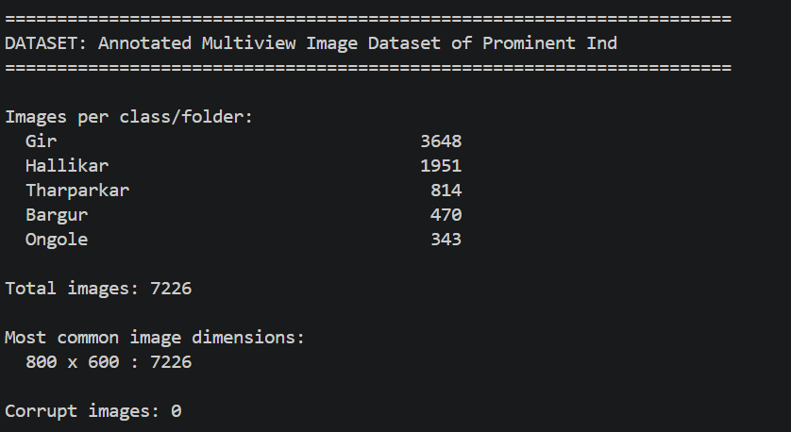

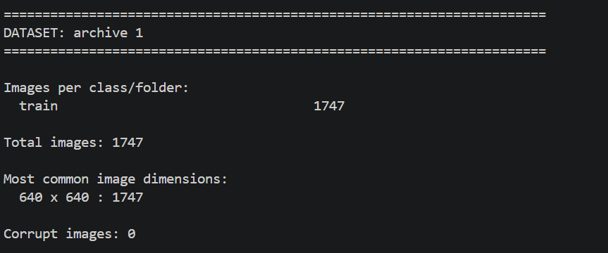

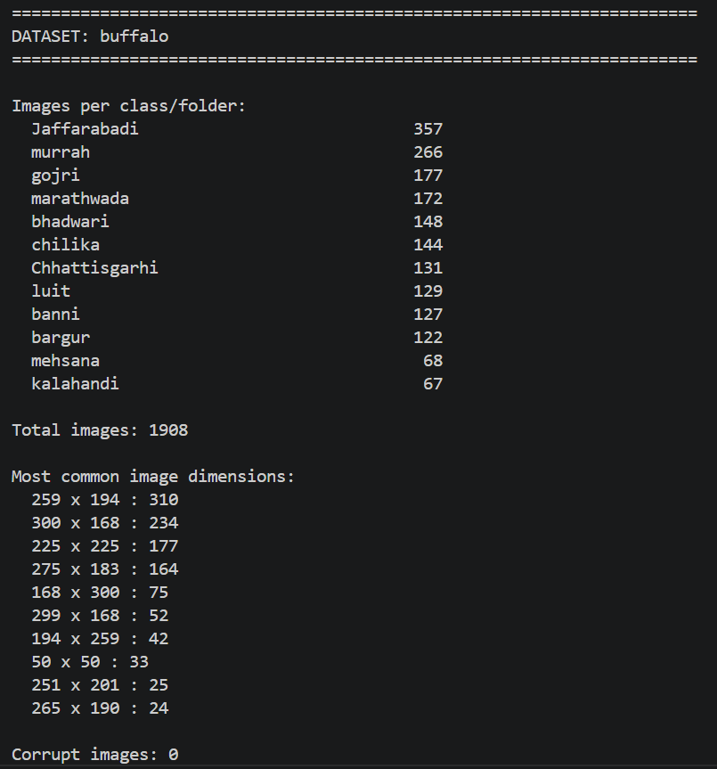
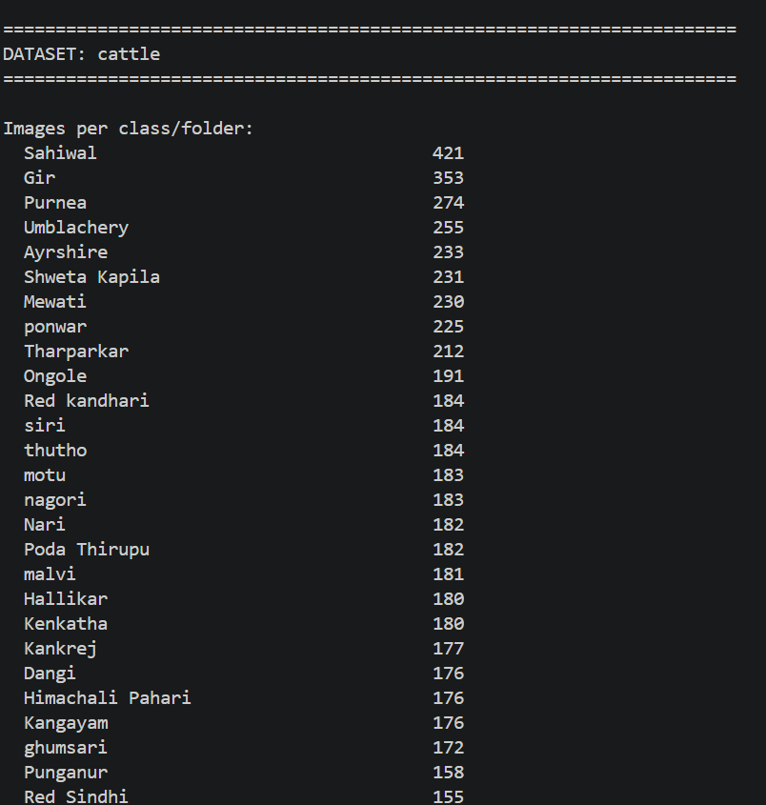
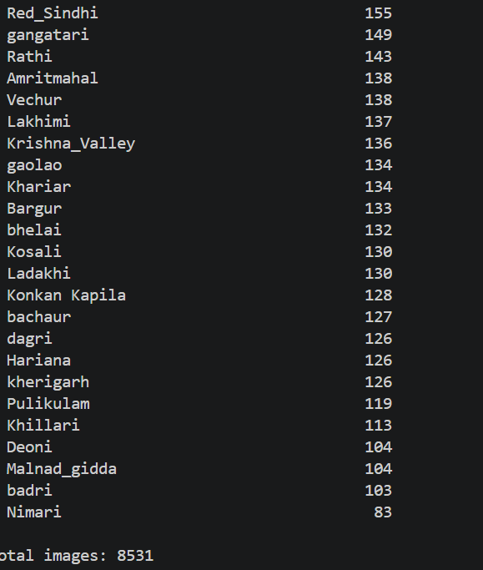
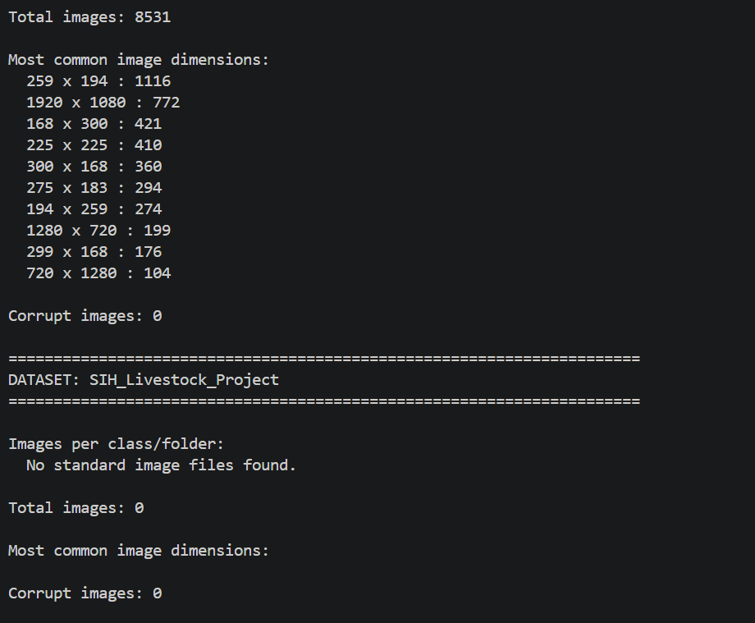
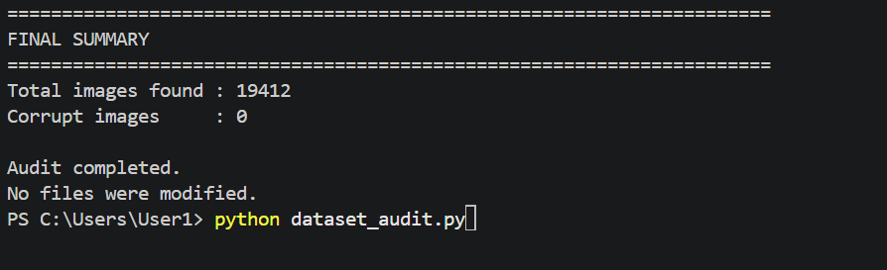

Dataset | Images | Corrupt | Main use
IICBD | 7,226 | 0 | High-quality cattle
Detection dataset | 1,747 | 0 | Cattle/buffalo detection
Buffalo breeds | 1,908 | 0 | Buffalo breed recognition
Cattle breeds | 8,531 | 0 | Cattle breed recognition
Total | 19,412 | 0 | —

Checking duplication in two datasets for cleaning

CATTLE

from pathlib import Path
import hashlib
from collections import defaultdict

ROOT = Path(r"D:\#SIH 2026")

IMAGE_EXTENSIONS = {
".jpg", ".jpeg", ".png", ".bmp", ".webp", ".tif", ".tiff"
}

def file_hash(path):
sha256 = hashlib.sha256()

with open(path, "rb") as f:
while True:
data = f.read(1024 * 1024)

if not data:
break

sha256.update(data)

return sha256.hexdigest()

# Find cattle dataset
cattle_folder = ROOT / "cattle"

# Find IICBD automatically
iicbd_folder = None

for folder in ROOT.iterdir():
if folder.is_dir() and "Annotated Multiview" in folder.name:
iicbd_folder = folder
break

if not cattle_folder.exists():
print("Cattle folder not found.")
exit()

if iicbd_folder is None:
print("IICBD folder not found.")
exit()

print("=" * 70)
print("DUPLICATE IMAGE CHECK")
print("=" * 70)

print("\nCattle dataset:")
print(cattle_folder)

print("\nIICBD dataset:")
print(iicbd_folder)

# ---------------------------------------------------------
# Collect cattle images
# ---------------------------------------------------------

cattle_images = [
p for p in cattle_folder.rglob("*")
if p.is_file() and p.suffix.lower() in IMAGE_EXTENSIONS
]

print(f"\nCattle images: {len(cattle_images)}")

# ---------------------------------------------------------
# Collect IICBD images
# ---------------------------------------------------------

iicbd_images = [
p for p in iicbd_folder.rglob("*")
if p.is_file() and p.suffix.lower() in IMAGE_EXTENSIONS
]

print(f"IICBD images: {len(iicbd_images)}")

# ---------------------------------------------------------
# Hash cattle images
# ---------------------------------------------------------

print("\nHashing cattle images...")

cattle_hashes = defaultdict(list)

for i, image in enumerate(cattle_images, 1):

try:
h = file_hash(image)
cattle_hashes[h].append(image)

except Exception as e:
print("Error:", image, e)

if i % 500 == 0:
print(f"Processed {i}/{len(cattle_images)}")

# ---------------------------------------------------------
# Check IICBD against cattle
# ---------------------------------------------------------

print("\nChecking IICBD against cattle...")

duplicate_pairs = []

for i, image in enumerate(iicbd_images, 1):

try:
h = file_hash(image)

if h in cattle_hashes:

for cattle_image in cattle_hashes[h]:

duplicate_pairs.append(
(cattle_image, image)
)

except Exception as e:
print("Error:", image, e)

if i % 500 == 0:
print(f"Processed {i}/{len(iicbd_images)}")

# ---------------------------------------------------------
# Results
# ---------------------------------------------------------

print("\n" + "=" * 70)
print("RESULTS")
print("=" * 70)

print(f"\nCattle images checked : {len(cattle_images)}")
print(f"IICBD images checked : {len(iicbd_images)}")
print(f"Exact duplicate pairs : {len(duplicate_pairs)}")

if duplicate_pairs:

print("\nDUPLICATES FOUND:")
print("-" * 70)

for cattle_image, iicbd_image in duplicate_pairs[:50]:

print("\nCattle:")
print(cattle_image)

print("IICBD:")
print(iicbd_image)

if len(duplicate_pairs) > 50:
print(
f"\nOnly first 50 shown. "
f"Total duplicate pairs: {len(duplicate_pairs)}"
)

else:

print("\nNo exact duplicate images found.")

print("\n" + "=" * 70)
print("CHECK COMPLETE")
print("No files were modified.")
print("=" * 70)

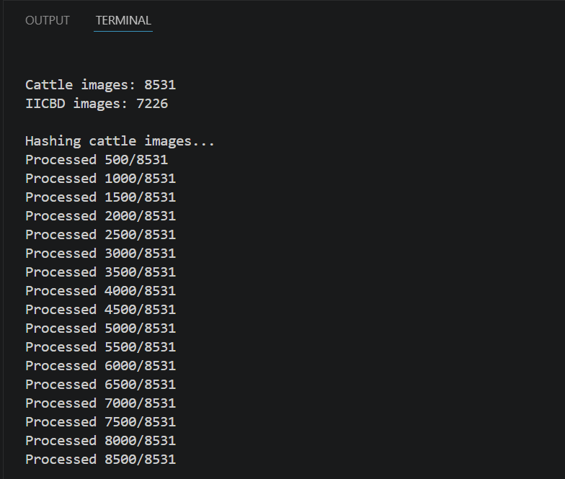

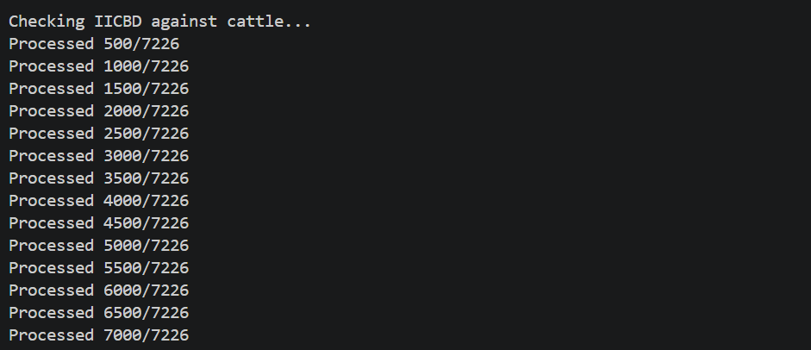

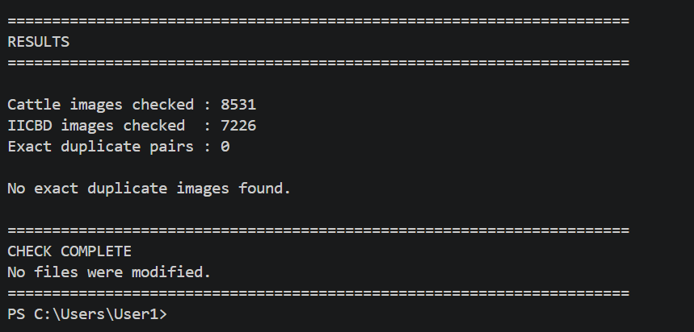

Breed | Cattle | IICBD | Combined
Gir | 353 | 3,648 | 4,001
Hallikar | 180 | 1,951 | 2,131
Tharparkar | 212 | 814 | 1,026
Bargur | 133 | 470 | 603
Ongole | 191 | 343 | 534

BUFFALO

from pathlib import Path
import random
from PIL import Image, ImageDraw, ImageFont

ROOT = Path(r"D:\#SIH 2026\buffalo")
OUTPUT = Path(r"D:\#SIH 2026\buffalo_label_check.jpg")

IMAGE_EXTENSIONS = {
".jpg", ".jpeg", ".png", ".bmp", ".webp"
}

IMAGES_PER_CLASS = 4
THUMB_WIDTH = 220
THUMB_HEIGHT = 180
LABEL_HEIGHT = 35

classes = [
folder for folder in ROOT.iterdir()
if folder.is_dir()
]

classes.sort(key=lambda x: x.name.lower())

rows = len(classes)
cols = IMAGES_PER_CLASS

sheet_width = cols * THUMB_WIDTH
sheet_height = rows * (THUMB_HEIGHT + LABEL_HEIGHT)

sheet = Image.new("RGB", (sheet_width, sheet_height), "white")
draw = ImageDraw.Draw(sheet)

for row, folder in enumerate(classes):

images = [
file for file in folder.rglob("*")
if file.is_file()
and file.suffix.lower() in IMAGE_EXTENSIONS
]

random.shuffle(images)
images = images[:IMAGES_PER_CLASS]

print(f"{folder.name}: {len(images)} images selected")

for col, image_path in enumerate(images):

try:
img = Image.open(image_path).convert("RGB")
img.thumbnail((THUMB_WIDTH - 10, THUMB_HEIGHT - 10))

x = col * THUMB_WIDTH
y = row * (THUMB_HEIGHT + LABEL_HEIGHT)

paste_x = x + (THUMB_WIDTH - img.width) // 2
paste_y = y + (THUMB_HEIGHT - img.height) // 2

sheet.paste(img, (paste_x, paste_y))

draw.text(
(x + 5, y + THUMB_HEIGHT + 5),
folder.name,
fill="black"
)

except Exception as e:
print("Error:", image_path, e)

sheet.save(OUTPUT, quality=95)

print("\nContact sheet created:")
print(OUTPUT)

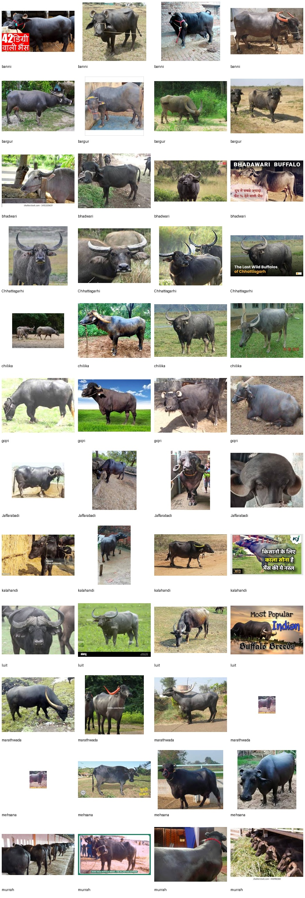
ENHANCING THE DATSET FOR BUFFALOS FOR CLARITY AND GOOD RESULTS
from pathlib import Path
from PIL import Image

ROOT = Path(r"D:\#SIH 2026\buffalo")

extensions = {".jpg", ".jpeg", ".png", ".bmp", ".webp"}

MIN_WIDTH = 128
MIN_HEIGHT = 128

total = 0
good = 0
small = 0
errors = 0

print("=" * 70)
print("BUFFALO DATASET QUALITY AUDIT")
print("=" * 70)

for folder in sorted(ROOT.iterdir()):
if not folder.is_dir():
continue

class_total = 0
class_good = 0
class_small = 0

for file in folder.rglob("*"):
if not file.is_file() or file.suffix.lower() not in extensions:
continue

total += 1
class_total += 1

try:
with Image.open(file) as img:
width, height = img.size

if width >= MIN_WIDTH and height >= MIN_HEIGHT:
good += 1
class_good += 1
else:
small += 1
class_small += 1

except Exception:
errors += 1

print(
f"{folder.name:<20} "
f"Total: {class_total:>4} | "
f"Good: {class_good:>4} | "
f"Small: {class_small:>4}"
)

print("\n" + "=" * 70)
print("FINAL RESULT")
print("=" * 70)

print(f"Total images : {total}")
print(f"Usable >=128x128 : {good}")
print(f"Very small images : {small}")
print(f"Read errors : {errors}")

print("\nNo files were deleted or modified.")
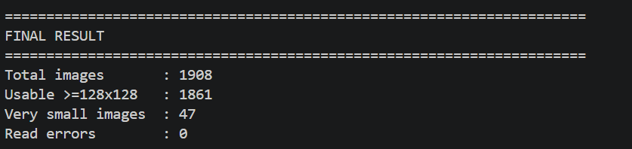

DELETING THE UNWANTED DATA
from pathlib import Path
from PIL import Image

ROOT = Path(r"D:\#SIH 2026\buffalo")

extensions = {".jpg", ".jpeg", ".png", ".bmp", ".webp"}

MIN_WIDTH = 128
MIN_HEIGHT = 128

print("=" * 70)
print("SMALL IMAGE ANALYSIS BY BREED")
print("=" * 70)

total_small = 0

for folder in sorted(ROOT.iterdir()):
if not folder.is_dir():
continue

small_images = []

for file in folder.rglob("*"):
if not file.is_file() or file.suffix.lower() not in extensions:
continue

try:
with Image.open(file) as img:
width, height = img.size

if width < MIN_WIDTH or height < MIN_HEIGHT:
small_images.append((file.name, width, height))
total_small += 1

except:
pass

if small_images:
print(f"\n{folder.name}: {len(small_images)} small images")

for name, width, height in small_images[:10]:
print(f" {name} -> {width} x {height}")

if len(small_images) > 10:
print(f" ... and {len(small_images) - 10} more")

print("\n" + "=" * 70)
print(f"TOTAL SMALL IMAGES: {total_small}")
print("=" * 70)

FINAL CLEANED DATA
SIH_Livestock_Dataset/
│
├── cattle/
│ ├── Bargur/
│ ├── Gir/
│ ├── Hallikar/
│ ├── Ongole/
│ └── Tharparkar/
│
└── buffalo/
├── Banni/
├── Bargur/
├── Chhattisgarhi/
├── Chilika/
├── Gojri/
├── Jaffarabadi/
├── Kalahandi/
├── Luit/
├── Marathwada/
├── Mehsana/
└── Murrah/

FINALISING INTO ONE FOLDER…

Splitting the data set into training, testing and value…

On splitting
Split
- Training: 6,997 → 69.93%
- Validation: 1,493 → 14.92%
- Testing: 1,516 → 15.15%

